**EXPORT TEST CASES**

In order to export test cases, you need to be in the Test Grid View first.

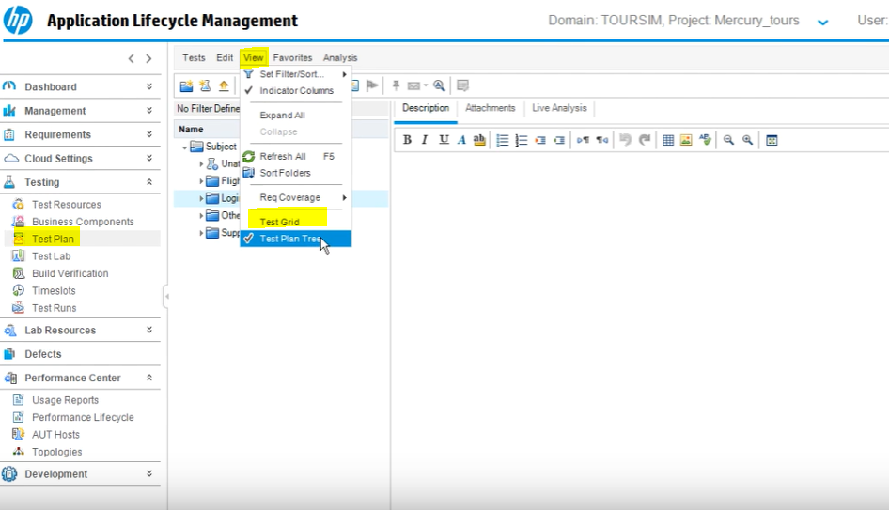

Right click and export

